1.

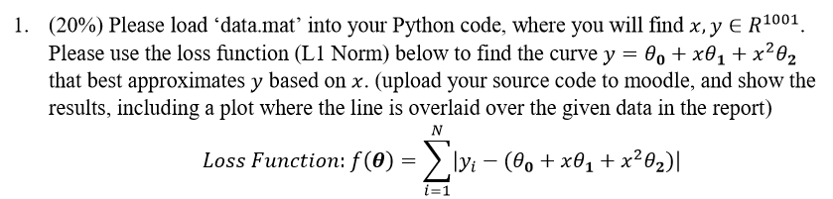

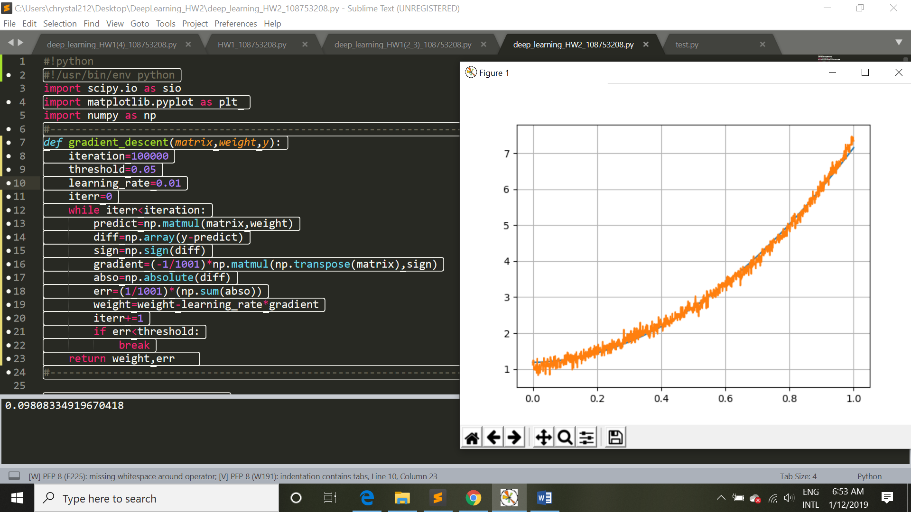

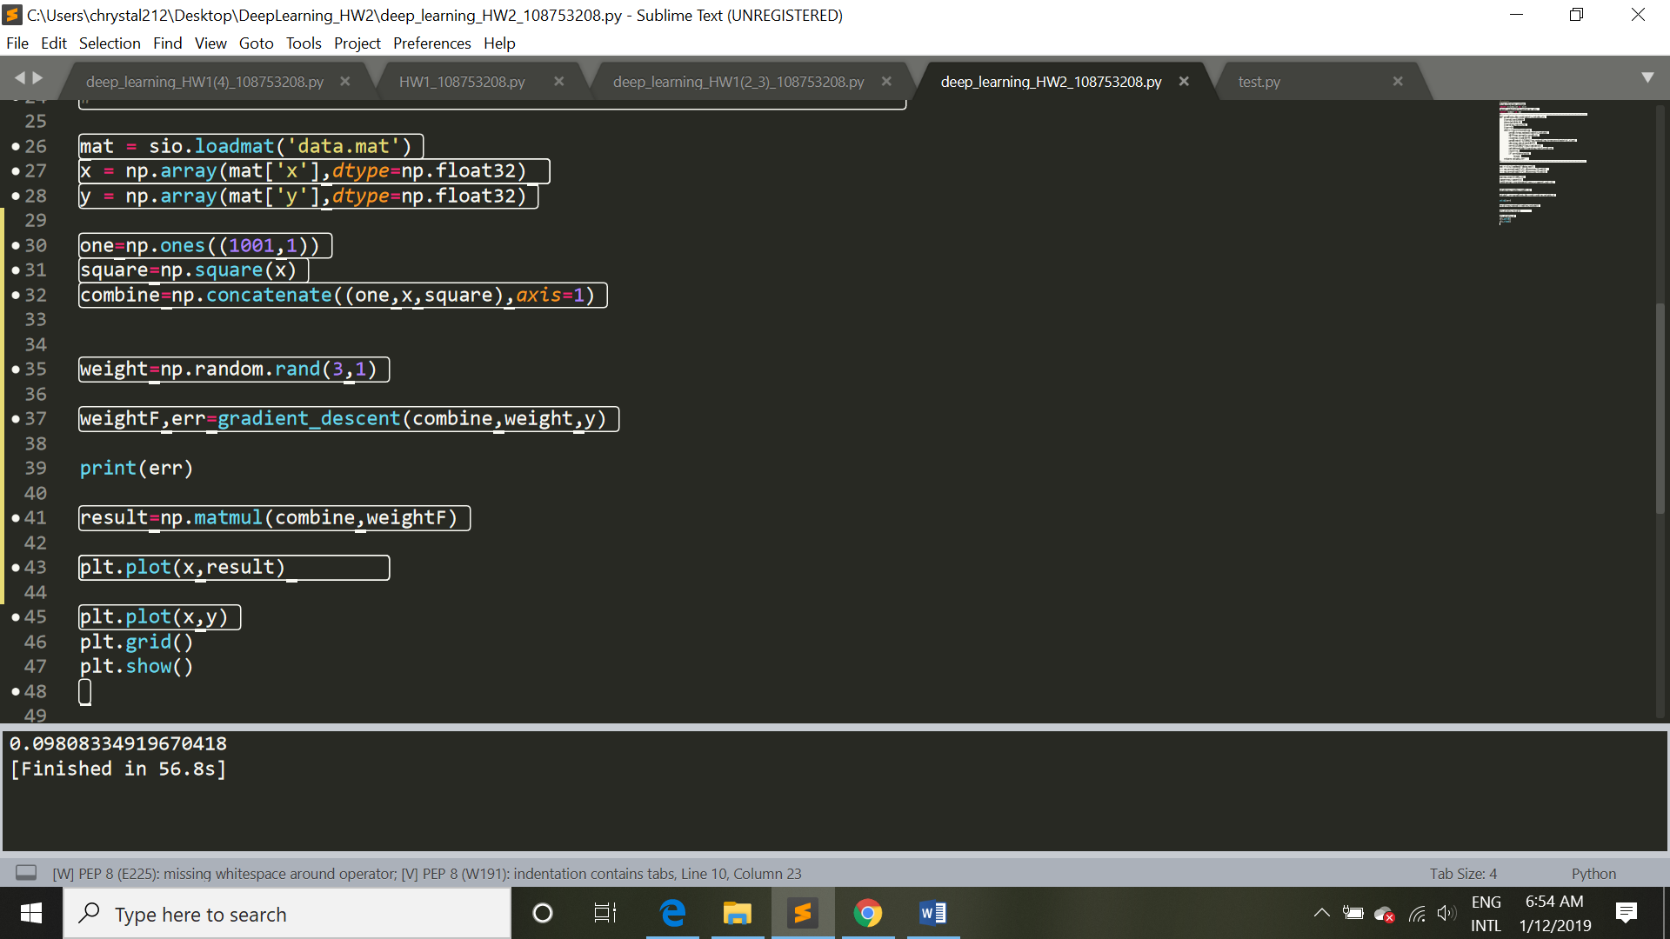

Prediction curve:

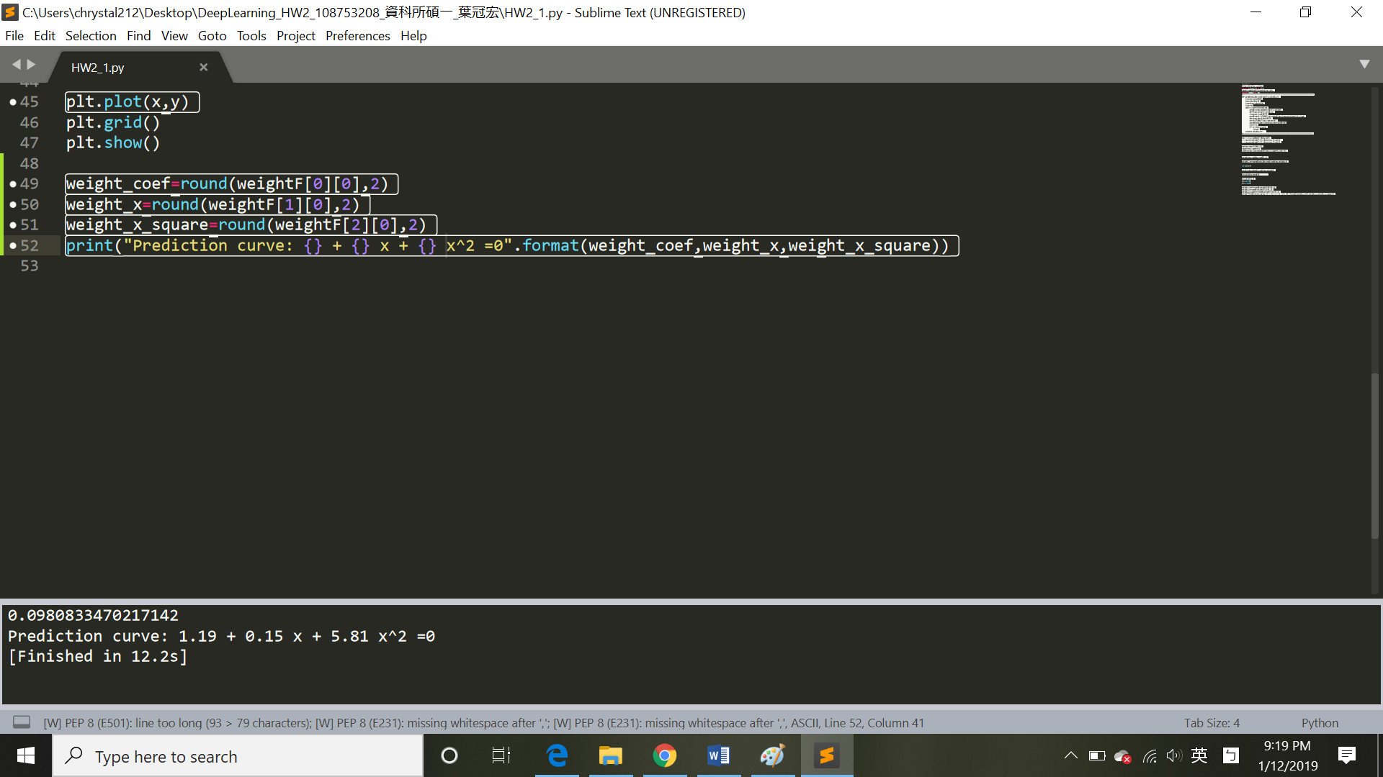

2.

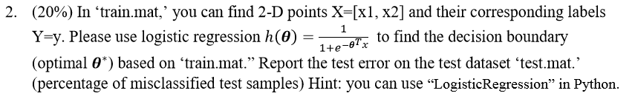

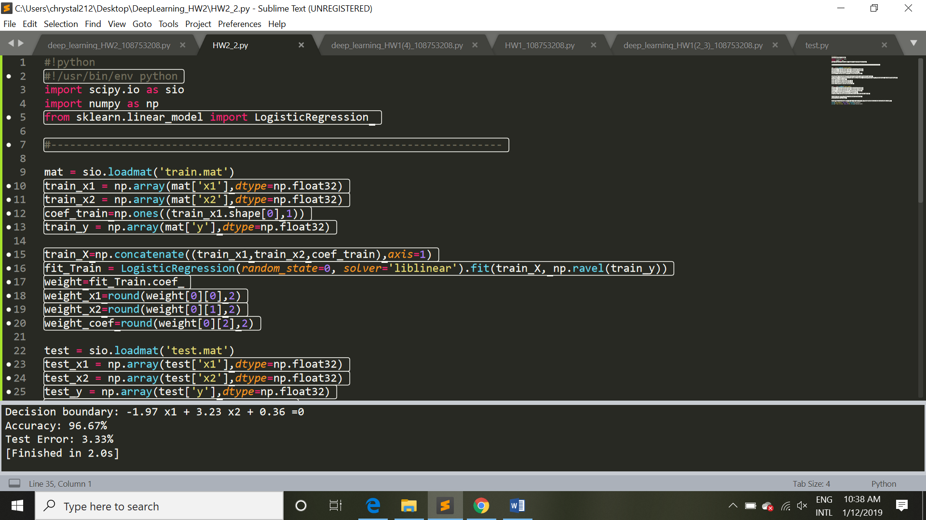

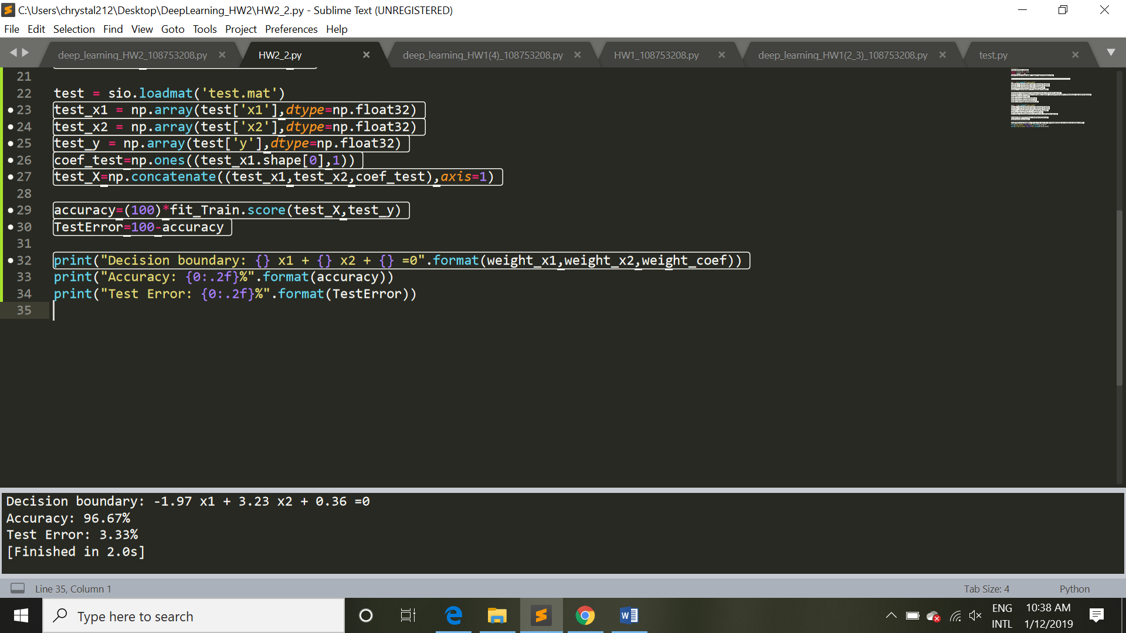

Decision Boundary: -1.97 x1 + 3.23 x2 + 0.36 =0

Test Error: 3.33%

3.



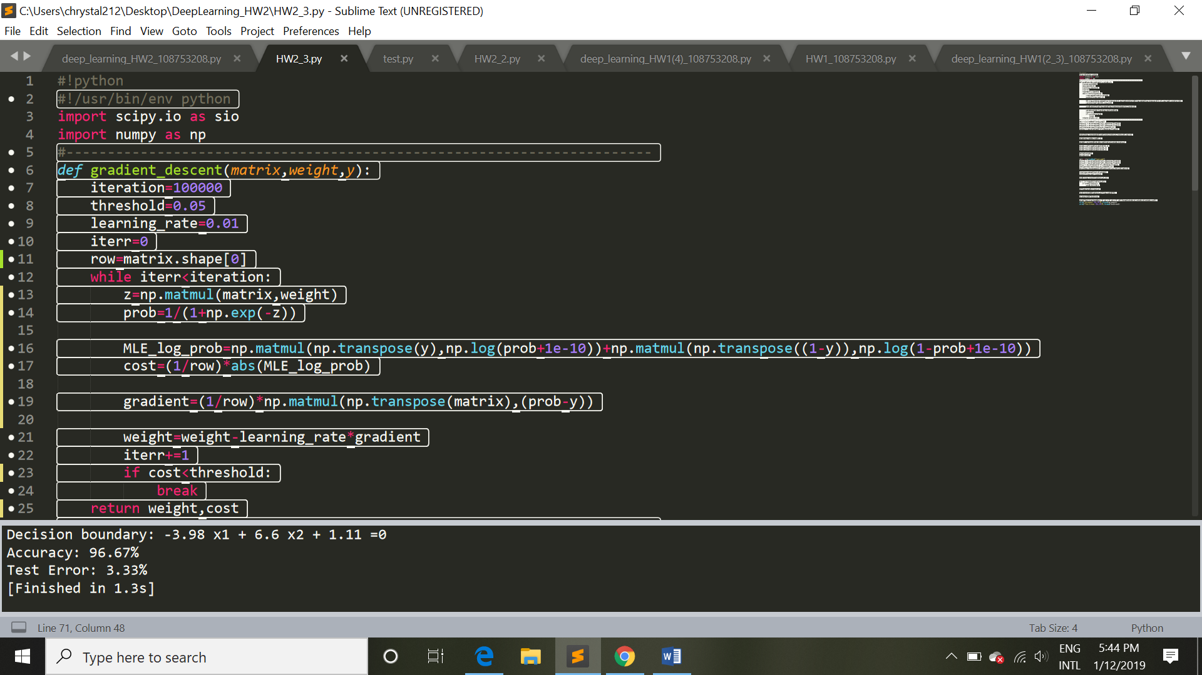

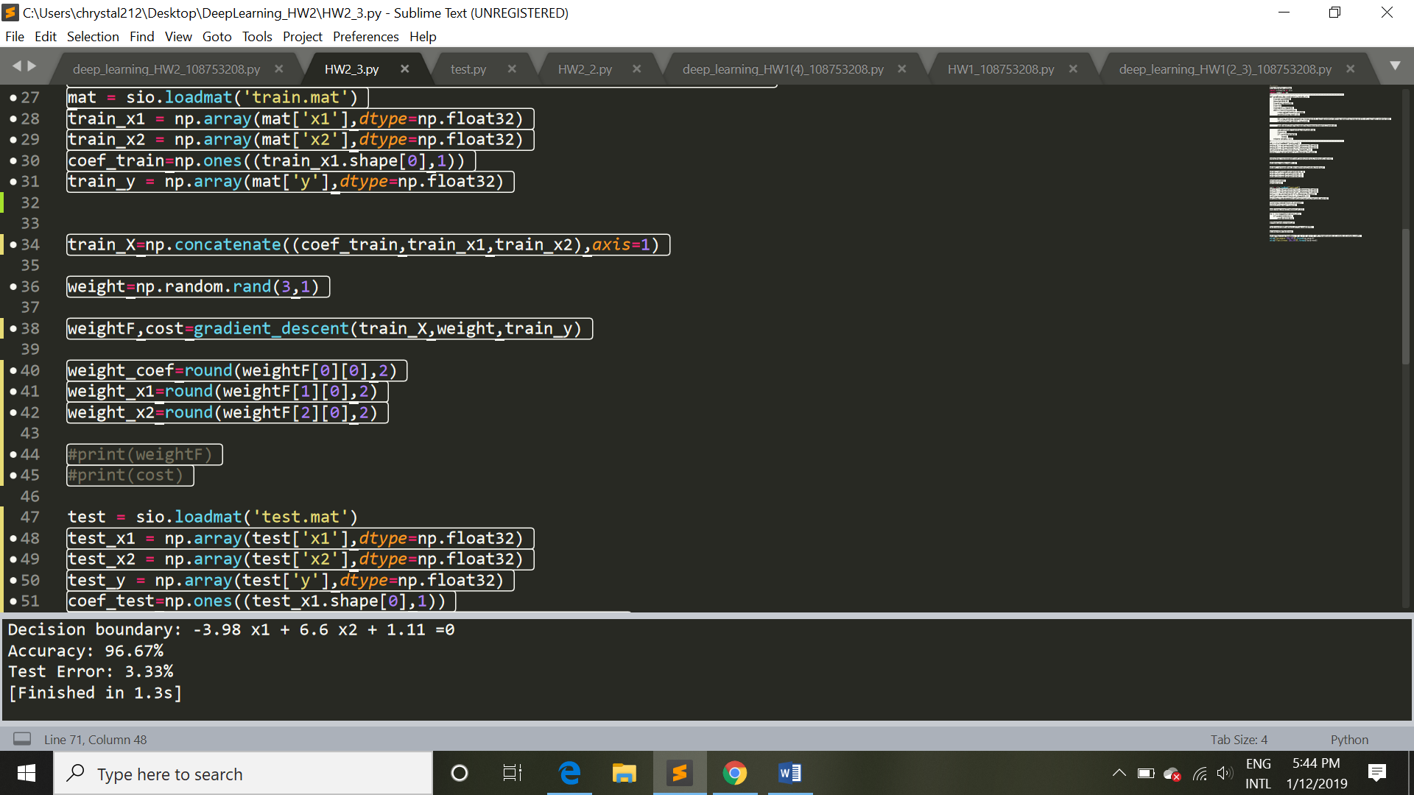

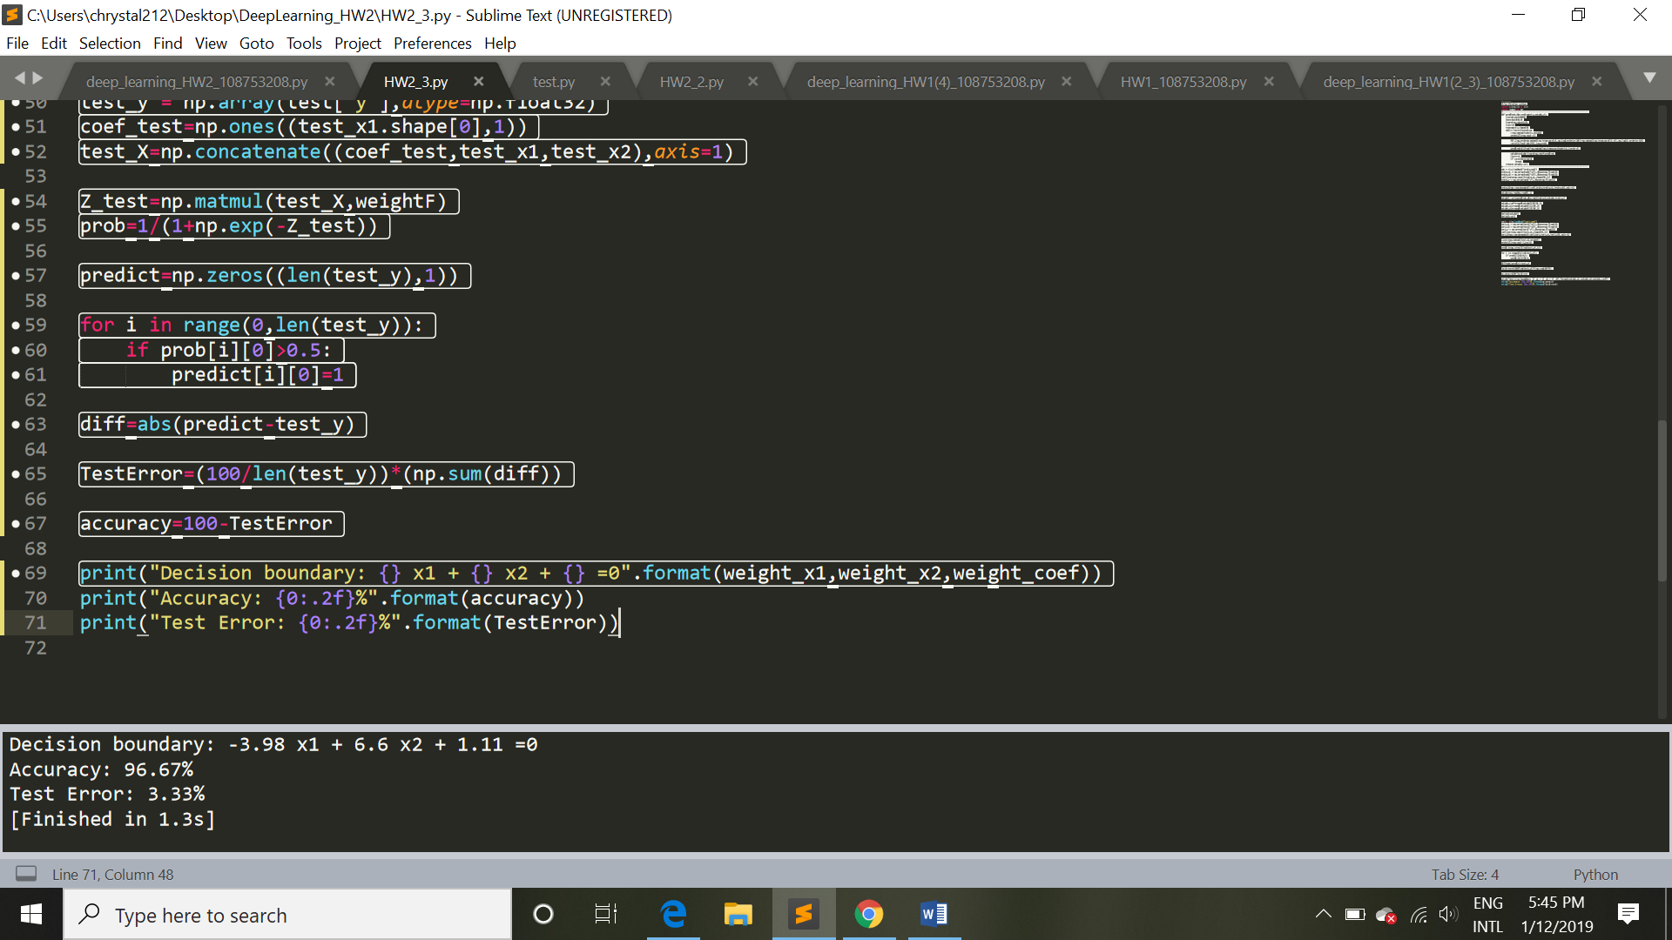

Decision Boundary: -3.98 x1 + 6.6 x2 + 1.11 =0

Test Error: 3.33%

4.

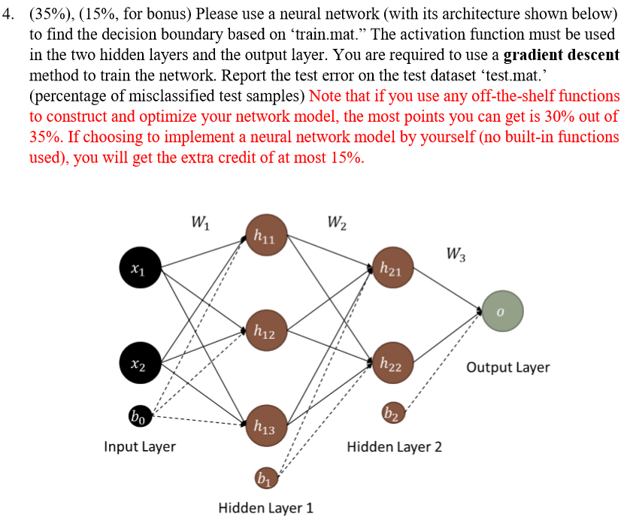

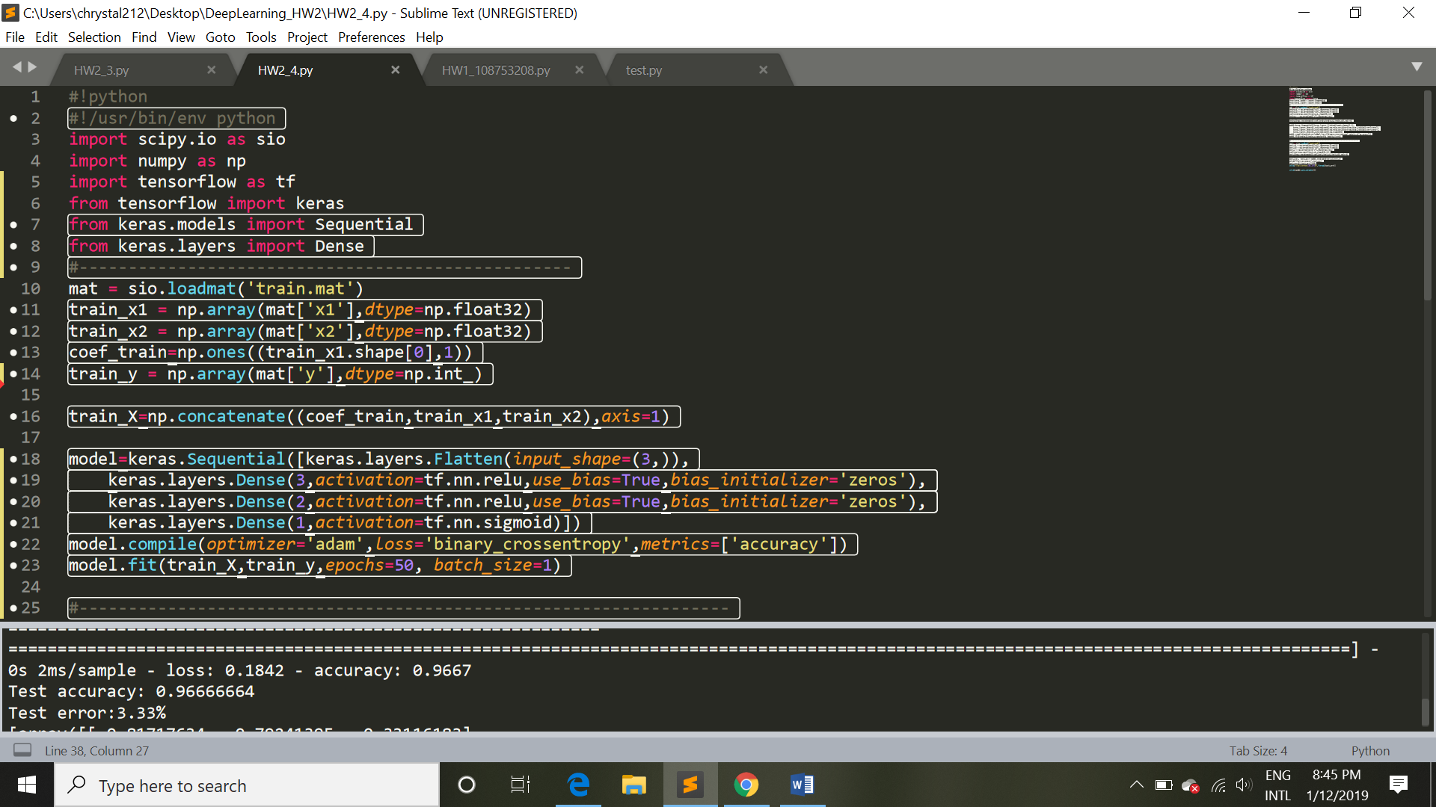

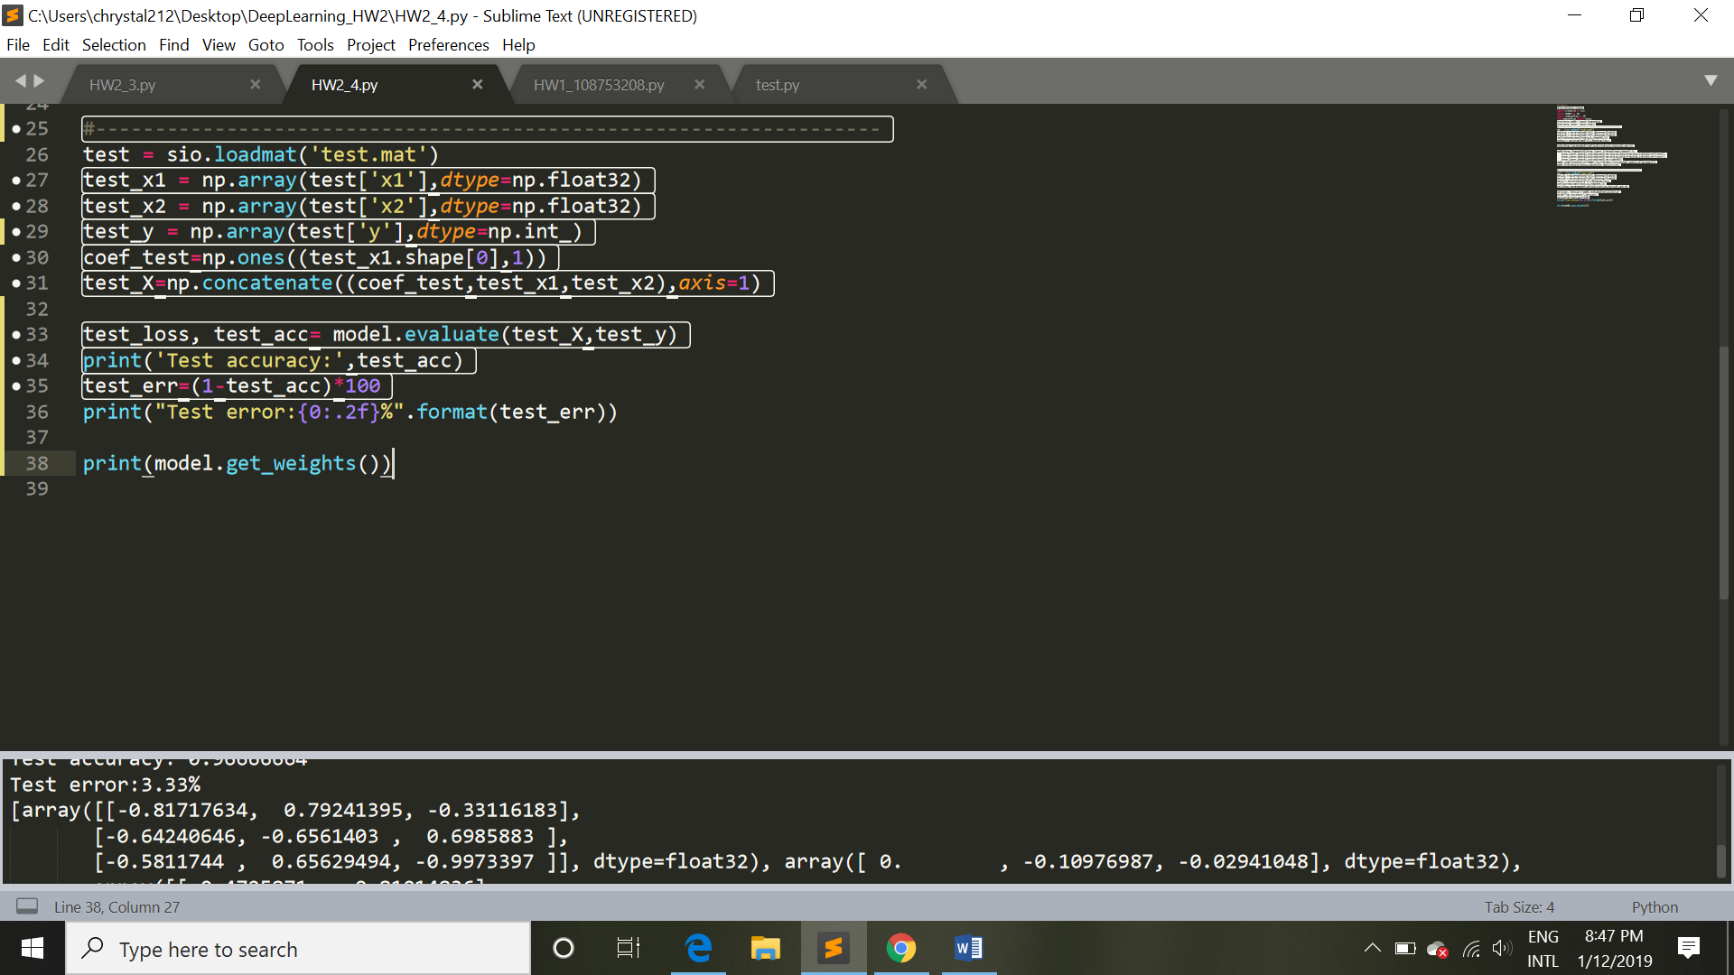

Test error:3.33%

Input Layer to Hidden Layer1 weights:



Hidden Layer1 to Hidden Layer2 weights 和 Hidden Layer2 to Output Layer:



其中Hidden Layer2 to Output Layer 的activation function 為 sigmoid。其 weight 及bias可當最後一層的Decision Boundary。